**PROJECT ON**

**“**STUDY OF STEAM GENERATION, DISTRIBUTION, APPLICATION OF PROCESS STEAM AND ACCOUNTING OF LOSSES**”**



**INDIAN INSTITUTE OF TECHNOLOGY BHUBANESWAR**

**ODISHA**

Under the guidance of:

**Mr. V. S. DEWANGAN**

**(AGM, PBS)**

# Submitted By

**VIJAY KUMAR MASIYARE MECHANICAL ENGINEERING . (13ME01020)**

**PREFACE**

**The trick to having good ideas is not to sit around in glorious isolation and try to think big thoughts. The trick is to get more parts on the table.**

*-* [Steven Johnson](http://www.goodreads.com/author/show/1563.Steven_Johnson)

If a picture is worth thousand words then a face to reality is priceless.

Project provides an engineer one such opportunity to explore the practical aspects of one’s technical knowledge apart from giving a firsthand experience to the professional work environment and opportunity to meet the strong technical work force.

We would like to thank everyone concerned for their time, enthusiasm and effort. Bhilai Steel Plant provided all the data needed for the project.

The project report focuses on the ways to recycle the sludge, obtain from BOFs and use them in efficient ways to reduce the wastage of Bhilai Steel Plant. Each of them are having cost effective advantage on one hand and substantially reduced dumping of waste on the other.

Finally, we regret any inadvertent errors that might have crept in. We hope that reading these proceedings is joie-de-vivre.

**ACKNOWLEdge**

In preparing these proceedings we have been fortunate to receive valuable guidance, kind support, suggestions, inspiration and assistance from our guide and his colleagues. We greatly appreciate their generosity in devoting their valuable time to help us in pursuing this project.

It is with feelings of profound thankfulness and deep sense of gratitude that we acknowledge the invaluable guidance and consistent encouragement rendered to us by**Mr. V. S. DEWANGAN (AGM, PP-I)** Bhilai Steel Plant (SAIL), India. He spared valuable time from his busy schedule for us and helped us by guiding for the project.

Our sincere thanks **Mr. Swaraj, JUNIOR MANAGER, PBS-II** for all the help and resources that were made available to me.

We arealso thankful to **Md. RAFI, RAUNAK SURYAVANSHI, PANKAJ RATHORE, CHANDRAKANT GAGARE** AND all the respected individuals who were directly or indirectly involved inthe successful completion of our Technical project.

**CERTIFICATE BY THE SUPERVISOR**

Certified that the project work entitled **(“**STUDY OF STEAM GENERATION, DISTRIBUTION, APPLICATION OF PROCESS STEAM AND ACCOUNTING OF LOSSES**”)** is a bonafide work carried out at BSP by the student **VIJAY KUMAR MASIYARE** (ME) pursuing B.Tech. From **IIT-Bhubaneswar, Odisha**, under the guidance of Mr. V.S.DEWANGAN (AGM), PP-I**,** during (9th MAY, 2016 to 2nd JULY, 2016). The matter embodied in this project is original and has not been submitted for the award of any other degree.

-----------------------------

V.S.DEWANGAN

AGM,

PP-I

**OBJECTIVE**

The study and describes the generation of steam and distribution of steam line throughout the BSP and study the various losses in steam line through visual inspection and theoretically.

Main objective of this project is to find the different ways to reduce steam losses in steam line and to check whether it is feasible in Bhilai Steel Plant or not. In our project work we divided our observation in following different ways:

* Brief details of Bhilai steel plant
* Brief details of PP-I and its functions
* Functions and description of boiler
* Turbo generator and turbo blower and there function
* Various consumers of steam in BSP or Customer of PP-1
* Functioning and purpose of Steam in Blast furnace, CO battery, SMS-1, AUX shop, Rolling mill

**CONTENT**

**S.no. TOPIC**

|  |  |  |
| --- | --- | --- |
| 1. | INTRODUCTION-BHILAI STEEL PLANT |  |
| 2. | **BRIEF INTRODUCTION OF POWER AND BLOWING STATION (PP-I)** |  |
| 3. | **BOILERS EFFICIENCY AND PBS-2 AND BPTG** |  |
| 4. | **STEAM DISTRIBUTION LINE AND PURPOSE OF STEAM** |  |
| 5. | **LOSSES CALCULATION** |  |
| 6. | **CONCLUSION** |  |
| 7. | **REFERENCES** |  |

**1. INTRODUCTION­­: BHILAI STEEL PLANT**

The **Bhilai Steel Plant**, located in Bhilai, in the Indian state of Chhattisgarh, is India's first and main producer of steel rails, as well as a major producer of wide steel plates and other steel products. BSP - a symbol of Indo-Soviet techno-economic collaboration, is one of the first three integrated steel plants set up by Government of India to build up a sound base for the industrial growth of the country, The agreement for setting up the plant with a capacity of 1 MT of Ingot steel was signed between the Government of erstwhile U.S.S.R. and India on 2nd February, 1955, and after a short period of 4 years, India entered the main stream of the steel producers with the commissioning of its first Blast Furnace on 4th February, 1959 by the then President of India, Dr. Rajendra Prasad. Commissioning of all the units of 1 MT stage was completed by1961. In the initial phase the plant had to face many teething problems, mostly unknown to the workforce at the time, but by meticulous efforts and team-sprit, these problems were surmounted and the rated capacity production was achieved only within a year of integrated operation of the plant.

Thereafter, the plant was expanded to 2.5 MT capacity per year, and then to 4 MT of crude steel per year. Bhilai expanded its production capacity in two phases - first to 2.5 MT which was completed on Sept. 1, 1967 and the 4 MT stages, which was completed in the year 1988.

All the units of the plant have been laid out in sequential formation according to technological inter-relationship so as to ensure uninterrupted flow of in-process materials like Coke, Sinter, Molten Iron, Hot Ingots, as well as disposal of metallurgical wastages and slag etc., minimizing the length of various inter-plant communications, utilities and services.

**RAW MATERIAL SOURCES**

Bhilai has its own captive mines spread over 10929.80 acres. Iron ore from Dalli-Rajhara group of mines, 85 Km south-west of Bhilai. Limestone requirements are met by Nandini mines, 20 Km north of Bhilai and dolomite comes from Hirri in Bilaspur district, 135 Km north-east of the plant. To meet the future requirement of iron ore, another mining site Rowghat, situated about 100 km south of Rajhara, is proposed to be developed; as the ore reserves at Rajhara are depleting.

**CERTIFICATES and AWARDS**

Eleven - times winner of Prime Minister's Trophy for best Integrated Steel Plant in the country. The distinction of being the first integrated steel plant with all major production units and marketable products covered under ISO 9002 Quality Certification belongs to BSP. This includes manufacture of blast furnace coke and coal chemicals, production of hot metal and pig iron, steel making through twin hearth and basic oxygen processes, manufacture of steel slabs and blooms by continuous casting, and production of hot rolled steel blooms, billets and rails, structural, plates, steel sections and wire rods. The plant's Quality Assurance System has been awarded ISO 9001:2000 certification.

Not content with the Quality Assurance system for production processes, Bhilai has obtained ISO 14001 certification for its Environment Management System and for its Dalli Mines. Besides environment-friendly technology like Coal Dust Injection System in the Blast Furnaces, de-dusting units and electrostatic precipitators in other units, BSP has continued a vigorous forestation drive, planting trees each year averaging an impressive 1000 trees per day in the steel township and mines. A leader in terms of profitability, productivity and energy conservation, BSP has maintained growth despite recent difficult market conditions.

**PLANT OVERVIEW**

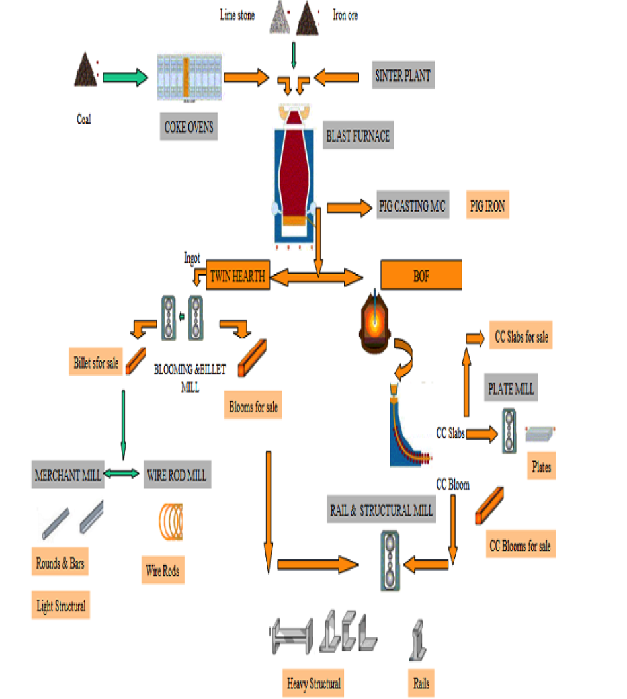

**MAJOR UNITS OF BSP:**

|  |  |
| --- | --- |
| **Coke Ovens Batteries: 10 Nos.** | * 8 batteries of 4.35m height consisting of 65 ovens each * 2 batteries of 7m height consisting of 67 ovens each |
| **Blast Furnaces : 7 Nos.** | * 3 Blast furnaces each of 1033 m³ volume * 3 Blast furnaces each of 1719 m³ volume * 1 Blast furnace of 2355 m³ volume |
| **Sintering Plants : 3 Nos.** | * SP-1 : 4x50sq.m hearth area * SP-2 : 3x75sq.m hearth area,1x80sq.m hearth area * SP-3 : 1x320sq.m hearth area |
| **Steel Melting Shop-I** | * 4 Twin Hearth Furnaces |
| **Steel Melting Shop-II** | **Convertor Shop :**   * 3 BOF 110/130 T Convertors * Secondary Refining facilities : 1 VAD unit, 130 T 2 RH degassers,   2 Ladle furnaces  **Continuous Casting Shop:**   * 4 Slab Casters, 1bloom caster, 1Combi caster |
| **Mills** | * Blooming & Billet Mill * Rail & Structural Mill * Plate and Merchant Mill * Wire Rod Mill |
| **Auxiliary Units** | * Two captive Power Plants - one captive and other in joint venture with   123 MW power generation capacity   * Two Oxygen Plants, Acetylene Plant, Propane Plant * Refractory Materials Plants for production of Mag Carb bricks, sinter,   dolomite, lime   * Foundry & Engg. Shops for captive manufacture of spares, assemblies,   mould, forging   * Coal Chemicals units for recovery of various by-products from coal   Carbonization, Slag granulation plants |

**MAJOR PRODUCTS OF BSP:**

|  |  |  |  |
| --- | --- | --- | --- |
| **SHOP** | **PRODUCTS** | **ANNUAL CAPACITY**  (tons) | **END USE & CONSUMERS** |
| Rail & Structural Mill | Rails  Heavy Structural  Crane rails  Crossing Sleepers | 750000 | Indian Railways, Export  Infrastructure Projects  Cranes  Broad gauge sleepers |
| Merchant Mill | Lt. Structural  TMT  Round | 5,00,000 | Engineering and Infrastructure Projects |
| Wire Rod and Mill | Wire Rods(Plain)  Wire Rods (TMT) | 4,00,000 | Electrodes Manufacture Infrastructure Projects |
| Plate Mill | Plates | 9,50,000 | Boilers, Defence, Railways, Ship building, LPG cylinders, Irrigation  Export |
| Semis | Bloom, NWS  Slab & Billets from BBM  HC Bloom from CCS Slab from CCS | 5,53,000 | Re-rollers |
| Pig Iron |  |  | Foundry |
| By  Product | Coal Chemical  Processed Slag |  | Ammonia Sulphate (fertilizers)-RAJA  Granulated slag from CHSG Plants & SGP for cement manufacture |

* + 1. **BRIEF INTRODUCTION OF POWER AND BLOWING STATION (PP-I)**

Bhilai Steel Plant imports power supply from Chhattisgarh State Electricity Board (CSEB). The plant also has two generating stations Power Plant-1 and Power Plant-2.PP-2 is under NSPCL.

The power generating stations at BSP for 2.5 MT is of following capacities:

**PP-I: 3 x 12 MW + 1 x 15 MW = 51 MW**

Power & Blowing Station is a vital installation of Bhilai Steel Plant. It serves the following needs of the Plant.

1. Supplying Air Blast to Blast Furnaces at requisite parameters.
2. Meeting critical and emergency power requirements of the 2.5 MT. Units of Bhilai Steel Plant
3. Meeting the process steam needs of various shops for their safe/efficient operation.
4. Buffer consumer of available Blast furnace and Coke Oven gases to prevent their wastage/high pressure in the gas line network.

**POWER & BLOWING STATION HAS THE FOLLOWING MAIN SECTIONS:**

**Boiler House**

There are five Boilers Russian make and one IJT Make Boiler. Each boiler has steam production capacity of 150 T/Hr. at 4500 C & 44 ATM pressure. Each boiler is a multi-fuel fired boiler using Coal Dust, Blast Furnace gas, CO gas and PCM as fuel separately or in combination. The Russian make boilers are water tube, radiant, refractory walled, natural circulation, single drum, bottom supported whereas IJT make boiler is having dual drum, direct coal firing system which has been suitably modified to use Blast Furnace Gas and Coke Oven Gas at par with Russian Boilers.

Boiler No 1, 2, 5 & 6 are equipped with Electro Static Precipitator whereas Boiler No

3 & 4 have wet scrubber system for de-dusting of flue gases produced as a result of fuel combustion in the Boiler Furnace. There is an Ash Handling Pump House for wet disposal of bottom ash of boiler furnace hopper, scrubber and ESP to a distant place.

This pump house also handles Ash slurry from Blast Furnaces, SMS-1 and RMP-1.

Steam produced in Boiler House is sent to Turbine Hall through two no. of Steam

Collectors as Boilers and Turbines are operated in Battery System for steam. At present a project on Dry Fly Ash Collection System for ESPs is in progress. There are five boiler type TKZ - 150 - 2 - Russian make and one new boiler of ISGEC John Thompson Pvt. Ltd. The Russian make boiler are water tube, radiant, refractory walled, natural circulation, single drum, bottom supported, vertical boilers intended for generating superheated steam of 150 T/Hr. at drum pressure of 44 ATM and temperature of 4500 C. The furnace chamber is formed by screen tubes on all sides and top. The ISGEC John Thompson boiler is having same specification (Boiler is British make) except that it is having dual drum, direct firing system, an electrostatic precipitator and rotary air preheater. Originally all five Russian make Boiler were having wet ash collector system (scrubbers). Retrofitting of ESPs have been carried out in Boiler No.1, 2 and 5.

**The principal data of boiler as follows:**

**Boiler 1 to 5 Boiler - 6**

* Rated capacity - 150 T/Hr. 150 T / Hr.
* Working pressure - 44 ATM at drum 44 ATM at drum
* Feed water temperature - 150°C
* Superheated steam temp. - 450°C
* Working pressure at main steam valve-39 ATM 39 ATM
* Radiant surface of tubes - 601 m2
* Total heating surface - 3326 m2 3679 m2
* No of Safety valve installed - 4 Nos. 3 Nos.

The boiler uses coal dust, Blast furnace gas, Cock Oven gas, Pitch Creosote Mixture (a byproduct of cock oven Bhilai Steel Plant) as fuels separately or in combination. The pulverized coal burners (6 nos.) are fed by primary air. These burners are located on side walls, six PCM burners are fixed concentric with coal dust burners. BF gas burners (6 nos.) are located below coal dust burners. Co gas burners (4 nos.) are fixed on front wall.

**Coal dust preparation system**

Raw coal from raw coal bunker of boiler is fed to ball mill through raw coal feeder for crushing into powder form. Here a combination of cold air, warm air & Hot air is used to maintain outlet temperature of 650 C. The air is used as carrier of coal dust. The air-dust mixture is then passed through separator where bigger particles of coal are separated and fed back of Ball Mill for crushing again. The powder coal dust and air are then passed through cyclone where coal dust and air are separated. The coal dust gets accumulated in coal dust bunker and air is used to carry coal dust from bunker into boiler furnace for burning through mill fan. The capacity of Ball Mill (Tube mill type) is 16 T / Hr. The designed efficiency of the boiler is 85.18 % to 90.5 % depending upon the type of fuel used and their combination.

**Drum:**

Drum is designed for two stage evaporation. It is divided into three compartments with one central compartment having clear water and two side compartment known as salt compartments. Feed water from economizer enters into clear compartment. Steam takes off from the clear compartment, passes through 2nd stage super heater coil (with respect to flue gasses passage) to attemperator where pure condensate is mixed to control steam temperature, steam further goes through 1st stage super-heater coil (w.r.t. flue gas flow) and then goes to steam collector through main steam valve.

**Economizer:**

There is four stage economizer placed in the flue track where feed water enters at 150°C and after heating by flue gas, goes to clean compartment of the drum. Re-circulation pipeline with valve exists between drum and economizer for feeding the latter during starting and stopping of boilers.

**Air Preheater:**

The air preheater is of Tubular type and has two stage s placed in the flue gas passage after the economizer to get warm and hot air for Ball mill and secondary air for combustion. The cold air is supplied by F.D. Fans (2nos/Boiler).

**Scrubber:**

The dust laden gasses after preheating are passed through scrubber where water is sprinkled on the gases through nozzles and dust is removed. The dust free gases are then sucked by induced draft fans (2nos/Boiler) and are led to atmosphere through chimney.

**E S P:**

The electrostatic precipitator installed in boiler No. 1, 2, 5 & 6 efficiently removes the dust from gases to maintain environment norms. (150Mg/Nm3)

**Ash handling system:**

This unit of Power & Blowing Station is most critical. The slurry formed in the scrubbers ESPs, bottom ash from furnace is led to Ash handling pumps through tunnel to pump it out by ash slurry pipeline to ash pond situated at 6

Km from the slop. There are four strand of pumps having capacity of 300m3/hr. Each strand has two pumps in series.

Schematic diagram of working of Russian make boilers is given in Annexure 'A'.

**Turbine Hall:**

There are three no’s of Turbo-Generators (12 MW each) and 1no of 15 MW for electric power generation and 9 no. of Turbo-Blowers (3 no’s of 10 MW equivalent, 4 nos. of 12 MW equivalent and 2 nos. of 16.369 MW equivalent) to supply air blast 1 to 7 nos. blast furnaces installed. There are 10 nos. of High Pressure Feed water pumps supplying feed water to Boilers. Also there are 6 nos. Deaerator installed where dissolved Oxygen and other gases in the Condensate and Chemically treated water are removed. Turbines of these turbo machines get steam from boiler house through steam collectors. Process steam to various customers is also sent through this section.

Turbine of Turbo Generators 1 & 2 is single cylinder, 15 stage, condensing, and impulse reaction type with Curtis wheel. The rotor is directly coupled to generator by means of semi flexible coupling. The turbine has a normal speed of 3000 RPM and has 4 pass outs of steam i.e. bleeder, 2 regulable and 2 non regulable. The regulable bleeder supply steam at 8-13 Atm at 246°C and 1.2 - 2.5 Atm at 145°C for process steam and for deaerator. The non regulable bleeder supply steam to H.P. & L.P. heaters. The turbine to Turbo blowers are of single cylinder, 12 stage, condensing type directly coupled with compressor by means of flexible geared coupling and provided with 2 non regulable bleeders for regenerative system.

4 compressors of 1.0 M.T stage are single cylinder centrifugal type, with an intermediate air cooling system after 2nd stage. 4 compressors of 2.5 M.T stage are double cylinder centrifugal type, with inter cooling system. The 4 M.T blower is of axial type single cylinder without inter cooling. The turbines are equipped with hydro-dynamic system & speed regulators, in this system the impulse is proportional to the square of velocity of rotor. Presently project work of retrofitting of 15 MW generator in place of TB-3 is in progress which is likely to be commissioned in April 2006.

**Turbo - Blowers 9 Nos.**

* 3 of 2700 NM3/Min. (TBs 4, 5, 6) 3.6 atm Abs. Pressure (10000kw eq.)
* 4 of 3000 NM3/Min (TBs7, 8, 9, 10) 3.6 atm Abs. Pressure (12000kw eq.)
* 2 of 4200 NM3/Min (TBs 11, 12) 4.7 atm Abs. Pressure (16369kw eq.)

**The characteristics of the turbines of blowers are:**

Single cylinder impulse - reaction - one Curtis wheel velocity compounded 8 impulse stage and 3 reaction stages - compounded, condensing tube. Use steam at 35 atms. And 4350 C. Governing system with speed variation 2500 - 3250 RPM (for 9th / 10th Blower speed range is 3200 - 4500 RPM) Protection from over speeding, lubrication failure and axial shift. Emergency stop.

**Regulation of Turbine (For USSR Turbine)**

Hydro-Dynamic System impulse to the speed governor is given by changes in the output of sensitive centrifugal pump rigidly mounted on to turbine shaft. The speed governor is of the diaphragm type actuated by the oil pressure developed by the impulse pump. Oil pressure in the lubrication system is in between 0.4 to 1.0 Kg/ sq.cm.

**Auxiliaries:**

* Speed changing device-hand operated or by remote control.
* Axial shift relay trips the turbine in case axial movement exceeds safe limit.
* Turbines are coupled to generator or blowers by geared teeth coupling.

**Condenser:**

Each turbine has one surface type of condenser with separate 2-passwater flow. This type of design permits cleaning of turbine condenser tubes A Turbo-Generator in halves in succession without stopping the turbine but working with reduced load.

**Condensate pumps:**

There are 2 Nos. condensate pumps of 60 T capacities each to extract condensate from the condenser.

**Oil tanks:**

Oil required for lubrication of bearing and regulation system is filled inthese tanks. The main oil pump is mounted on the shaft of the turbine and supplies lubrication oil & regulation oil through injectors. Oil cooler are installed to cool the oil.

**Oil pumps:**

There is main pump mounted on main shaft of turbine which supplies oil for lubrication and regulation purposes. There is an emergency oil pump which starts automatically when the oil pressure goes below predetermined pressure and supplies oil for lubrication purposes. One Auxiliary oil pump is there during the starting & stopping to take over M.O.P. supply.

**Ejector:**

As the condenser is a vacuum type so while starting the turbine it is necessary to produce vacuum in the condenser and to maintain it when turbine is running. It is a two stage ejector.

**Deaerators:**

Deaerators are the vessels where dissolved oxygen in the condensate and chemically treated water is removed as oxygen is corrosive. The deaerator are of atmospheric type and works at a steam pressure of 1.7 atm abs. And water temperature at about 1030C to 1050C. The deaerator water is then sent to boiler economizers through feed pumps. There are 6 nos. deaerators in all.

**Feed Water Pump:**

There are 10 no’s Boiler feed water pumps. 3 pumps can pumps 200T/Hr. & 7 pumps can pumps 100 T feed water to Boiler. Originally there pumps were Russian made out of which 5 have been replaced with KSB pumps.

**Main Control Room & Switch Gears**

Out of 270 MW maximum demand of Bhilai Steel Plant, Power & Blowing Station shares 51 MW with 4 generators having capacity of 12*3 MW +1*15 in operation.

This plant is connected to CSEB grid through 3 Nos. Tie Lines. Apart from supplying its own auxiliaries it also feeds power supply to vital consumers such as Coke Ovens, Blast Furnaces 1 to 6, Sintering Plant – 1, SMS-1, Pump Houses, Oxygen Plant – 1, Compressed Air Station-2 and BESCL (Power Plant-2). The electrical wing of the shop looks after the operation and maintenance of all electrical equipment’s installed in Boilers, Turbine, WCTP, CHP and Repair Shop apart from maintaining own electrical installations like HT & LT Switch gears, transformers, Protections and other electrical related activity of the Shop. The Turbo Generator has Differential, Overload with minimum voltage blocking, earth Fault in Stator and Double Earth Fault in Rotor Protections to safe guard the equipment’s. It feeds the following vital consumers apart from supplying its own auxiliaries.

1 Coke Ovens

2 Blast Furnaces 1 to 6

3 SMS-1

4 Sintering Plant-1

5. RSM & BBM

6 PBS-2

**Coal Handling Plant:**

Power & Blowing Station receives Boiler Coal of D / E grade (UHV 4200 – 5200 Kcal /Kg) from Surakachar, Katkona and South Eastern collieries in railway wagons and unloaded at PG hopper slot bunker having capacity of 300 T, by manual labor. The coal unloaded at slot bunker of PG Hopper is conveyed to boiler bunkers through a series of single strand conveyors (6 no’s) after crushing them by a hammer crusher having a capacity of 120 T/Hr or a ring granulator of capacity 200 T / Hr. The crushed coal is first stored in the coal yard and then fed boiler bunkers as per requirement. The capacity of coal storage yard at Power & Blowing Station is 22500 Tones. The capacity of coal wagon unloading at PG hopper is 150 T/hr and feeding to raw coal bunker is 90 T /hr Power & Blowing Station receives Boiler Coal of D / E grade from Banki / Surakachar, Katkona and South Eastern collieries in railway wagons and unloaded at slot bunker having capacity of 300 T, by manual labors. The bigger size coal and coal in defective wagons are unloaded on line 41 A to augment coal unloading process to facilitate faster release railway wagons to avoid demurrage.

**The coal received from mines has the following properties:**

1) Useful heat Value - 4600 - 5600 K Cal / Kg

2) Ash content - 18 to 30 %

3) Volatile matter - 21 - 24 %

4) Moisture - 10 - 15 %

The capacity of coal storage yard at Power & Blowing Station is 22500 Tones.

The coal unloaded at slot bunker, is conveyed to boiler bunkers through a series of single strand conveyors. The coal is crushed by a crusher having a capacity of 90T/Hr and a ring generator of capacity 200T/Hr. there are 6 conveyors in all. The crushed coal is first stored in the coal yard and then fed boiler bunkers as per requirement.

**SAFETY**

**INTRODUCTION**

Accidents in a plant affect productivity and morale of workforce. All accidents, regardless of their consequences are symptoms of production inefficiency. Accident free production is regarded as an efficient production. Many activities and processes in a steel plant can present situations, which involve risk to Safety and Health of employees and risk of damage and loss to plant equipment and product. Hence, it is a moral, economic as well as legal duty of all especially the front line executives - to prevent, control or guard against such risks and their possible ill effects with an objective to achieve elimination of human suffering, damage to material and equipment and resultant loss of production, the Hindustan Steel Limited (HSL) laid a policy for accident prevention which was adopted by the committee of management in the meeting held at Durgapur on 25th August, 1972. Based on the principles expressed in that policy, the organization of Safety activities and program for accident prevention in the plants of Hindustan Steel Limited and at the Head office were outlined. It was stated that there should be a dynamic Safety Department in each plant and a suitable organization at the head office to implement the Safety policy and program and that the Safety department should have the status necessary for effective discharge of its functions.

After formation of the Steel Authority of India Ltd. the same policy was accepted in principle with a view to achieve year by year, a continuing reduction in the number of accidents and provide health working environments, the policy of accident prevention was revised and the revised Safety and Health policy of Steel Authority of India Limited was approved by the Board of Directors of SAIL in their 96th meeting held on 20-07-1983. This Safety Policy is applicable all units of SAIL. Bhilai Steel Plant is an OHSAS-18001 certified plant and it has developed its own Occupational Health & Safety Policy in addition to the SAIL Safety Policy.

# Safety Instruction:

Power & Blowing Station has been designated as a hazardous unit. In Boiler Blast Furnace Gas, Coke Oven Gas and hot PCM are used as fuels, so much so these lines run around and inside the shop. Also High pressure and Low pressure Steam & Water Line network engulfs the entire shop. There are H.T and L.T electrical installation and cables in and around the shop. Because of various processes involved in the handling of fuels, generation of steam, electricity and hot blast, many potential hazards such as High Noise Level, Heat Radiation, Coal dust, Fly Ash, Poisonous Gas leakages etc. exist. So all new entrants are strongly advised to understand the safety hazards before entering the shop.

In captive power plant safety revolves around mainly

1. Safety in the processes.

2. Safety of the personnel.

Safety of the person is more or less common as applied in any other parts departments of the plant but safety involved in processes is entirely different because of wide range of hazardous conditions required for the working of the plant.

**1. SAFETY IN THE PROCESSES.**

The operation of captive power Plant requires water, coal, gas, air, oil etc as input ingredient and steam, electricity, hot air blast, hot flue gases, hot dry fly ash as output products. Handling/processing of each ingredient poses potential safety hazards in and around the plant. Potential hazards involved with operation of the plant are classified on the basis of

A. Source/ equipment.

B. Medium.

C. Consequence.

**A. On the basis of source / equipment it is sub divided as**

Boiler- Furnace proper, coal dust preparation system, auxiliaries, ESP's etc.

Turbine/ Blowers - Turbine /blower proper, auxiliaries, air headers etc.

Generator / Motors - Generator proper, exciter, transformers, motors etc.

Coal Handling Plant - Yard, conveyor gallery, bulldozer etc.

Water Chemical Treatment Plant - Various chemicals.

Air compressors

**B. On the basis of medium it is sub divided in to**

* Steam
* Hot water- Feed water, condensate water, flushing water, cooling water.
* Oil - fuel oil, lubricating oil and grease.
* Gas - Blast Furnace Gas, Coke-oven gas, Converter gas.
* Chemical
* Electricity.
* Hot fly ash
* Hot air- Combustion air, air blast.
* Hot flue gases
* Coal- Lumps, fines
* Compressed air
* Sound

**C. On the basis of consequence it is divided in to**

* m. Gas poisoning.
* n. Explosion.
* o. Fire.
* p. Burn injury.
* q. Electrocution
* r. Diseases.

Detailed potential hazards of Power & Blowing Station of Bhilai Steel Plant is given in Annexure A.

**2. SAFETY OF THE PERSONALS**

Each individual working in the plant is required to adhere to basic safety norms/rules while discharging his duties. Violation of these safety norms/rules causes accident. Causes of the accidents can be explain as below:

**DIRECT CAUSES**

**Unsafe act**

Violation from the commonly accepted safe procedures of work is called unsafe act.

**Examples**

* Operating without authority.
* Failure to ensure.
* Bypassing safety device.
* Use of unsafe tools / tackles.
* Unsafe loading and placing.
* Taking unsafe procedure.
* Working on moving machinery / equipment.
* Non usage of PPE

**Unsafe condition (Hazards)**

Hazards are the condition with potential of causing injury to person or damage to equipment.

**Example**

* Unguarded machines.
* Defective machine.
* Unsafe design / construction.
* Improper illumination.
* Poorhouse keeping.
* Lack of proper tools.
* Slippery floor.

**INDIRECT CAUSES**

These factors are contributing factors which give rise to direct cause.

**Lack of knowledge and skill**

* Incorrect knowledge.
* Incomplete knowledge.
* Unskilled / low degree of skill.
* Misunderstanding job instructions.

**Improper physiological / anatomical characteristics persons of**

* Poor eyesight.
* Hard of hearing.
* Overage.
* Sick.
* Allergic.
* Intoxication.

**Improper psychological characteristics persons who are**

* Arrogant.
* Lazy
* Fearful.
* Nervousness.
* Egoistical.
* Absent minded.
* Over confident etc.

Some common conditions/ reasons for physical injuries related with the operation of captive power plant are as followed:

**A. Injuries due to fall from height:**

Although measures are taken to ensure safety at heights, in some cases, fencings railings are not provided or during maintenance or otherwise the fencing are removed.This unfenced work places at heights may cause fall of persons. In some cases, open are allowed during maintenance work without its fencing. Also in some cases workers do not use safety belt properly while working at heights or use temporary ladders, scaffolding, stairs. These also are potentially hazardous condition, which may lead to fall of workers.

**B Slip and fall at same level:**

This is a leading factor causing a number of injuries, although minor in nature. In thermal power stations, coal, oil etc. are used. Deposits of coal, dust / ash and its mixing with moisture/ dew on the floors, ladders/ stairs makes them slippery. In addition to this seepage of oil near the oil storage tanks/ pipes, equipments/ gearboxes may cause slipping of persons on slippery floors. In addition, a number of injuries have been reported in various thermal power stations due to poor house-keeping or inattention of the employees. In some cases, workers have slipped due to obstructions and raises structures.

**C. Slackness / shortcut approach in maintenance:**

As we know that maintenance is an integral part for the operation of the plant, injuries also occur due to deviation from Standard Maintenance Practice. Slackness/ shortcut approach, psychological behaviors, absence of understanding between co-workers, in-adequate knowledge about jobs etc. are the prime reasons for accidents.

**Gas Poisoning:**

In captive power plants by-product gases Blast Furnace Gas, Coke-oven Gas, Converter Gas are used as a fuel in the Boilers. These gases contain some quantity of Carbon Monoxide as shown in table 1. Carbon Monoxide combines easily with the hemoglobin of the blood, forming unstable compound called carboxy - hemoglobin. The affinity of Carbon Monoxide for the blood is 210 times more than the oxygen. So, even if a small quantity present in the air hemoglobin in the blood will absorb Carbon Monoxide than the oxygen. When this happen, the capacity of the hemoglobin carrying oxygen to the tissues of the body is reduced. More and more breathing of CO displaces oxygen, causing the body to suffer from oxygen starvation thus resulting in asphyxia. Many times minor leakage in the gas circuit near tempers, valves, sector gate etc. makes the area uncomfortable. Operators assuming these conditions not abnormal goes near the leaking point and suffer with gas poisoning. Some times during starting / stopping activities of the gas line result in heavy leakage due to failure of packing or mal-operation. This affects masses severely working in the vicinity.

**SYPTOMS AND EFFECT**

|  |  |
| --- | --- |
| * Headache | * Mental dullness |
| * Tightness in chest | * Vomiting |
| * Dizziness | * Yellowness in front of eyes |
| * Weakness in limbs | * Unconsciousness |

**FIRST-AID IN CASE OF GAS EXPOSURE**

|  |
| --- |
| * Take the victim away from the gas affected area to the fresh air (opposite to the wind direction). |
| * Loosen the tight fitting clothes, shoes and belt so that, victim can breath comfortably. |
| * Ask the victim to take longer breath (if conscious). |
| * Give Oxygen to the victim if possible. |
| * Provide artificial respiration (if required). |
| * Send the victim to nearest Medical Centre for medical aid |
| * Inform Gas Safety to take sample of the area. |

**Precautions:**

Use of personal protective Equipments (PPE’S)

* Hand gloves
* Helmets
* Safety shoes
* Goggles
* Portable gas monitor
  + 1. **BOILERS EFFICIENCY AND PBS-2**
  1. **BOILERS: -**

Steam boiler is basically a closed vessel into which water is heated until it is converted into steam at required pressure. The water must be first treated to remove impurities (chlorides, other salts, oxygen & solid particles) which will cause problem in turbine. When water has been purified it is stored in the closed vessel and fuel (PCM, CO gas, BF gas & coal) is burnt in a furnace and hot gases are produced. These gases come in contact with the vessel and raise the temperature of the vessel above boiling point of water at that given pressure.

**Types of boiler: -**

* 1. **Fire Tube boiler: -**

In fire tube boiler, there are number of tubes through which hot gases are passed and water surrounds these tubes. It is quite compact in structure, cheap and fluctuation of steam can be met easily.

However, it requires long time for rising steam at desired pressure. The steam received from fire tube boiler is not very dry.

* 1. **Water tube boiler: -**

Water tube boiler are just opposite to the fire tube boiler in these the water is heated inside the tubes and hot gases surrounds these tubes. Large heating surface can be achieved by using more number of water tubes. Due to convectional flow, movement of water is much faster than that in fire tube boiler, hence rate of heat transfer is high which results into high efficient method. However, it is not compact in construction and is not cheap.



**GENERAL FLOW DIAGRAM OF BOILER FUEL SYSTEM (MULTIFUEL)**

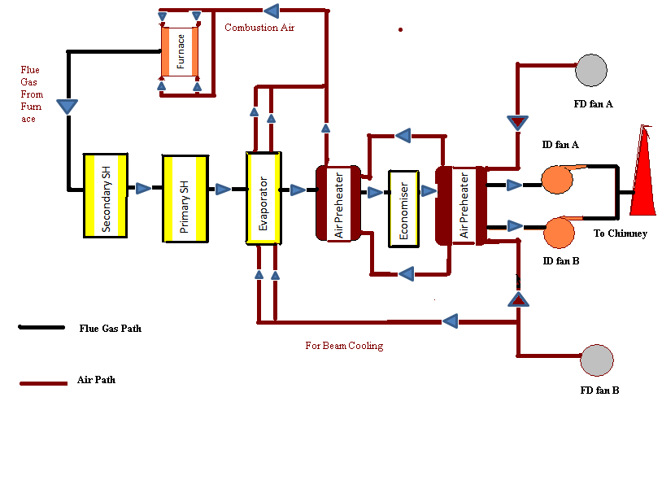

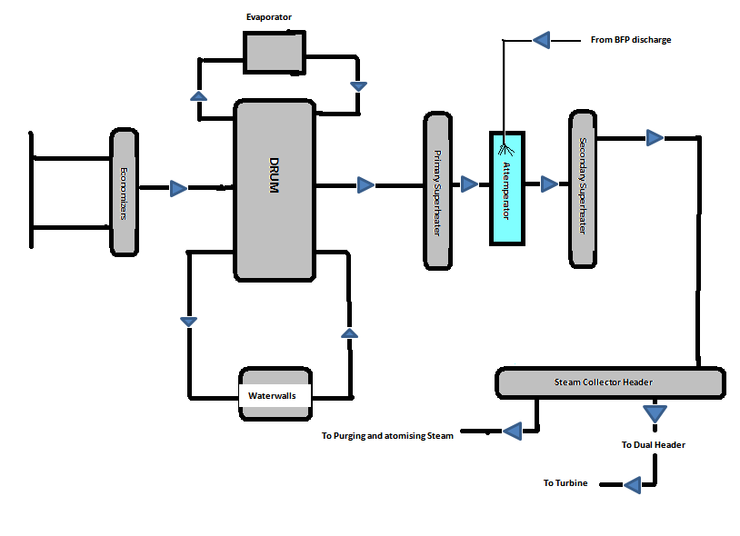

* 1. **BOILER EFFICINCY: -**

**Calorific value (C.V.) and flow rate of consumed fuel:**

|  |  |  |  |  |
| --- | --- | --- | --- | --- |
| **S.NO.** | **FUEL** | **C.V.(calorific value)** | **Flow rate ()** | **Enthalpy = C.V. (MW)** |
| 1. | **BF gas** | 850Kcal/m**³** | 173690 nm**³**/hr. | 171.42 |
| 2. | **C O gas** | 4250Kcal/m**³** | 45751 nm**³**/hr. | 225.768 |
| 3. | **PCM (pitch creosote mixture) oil** | 8644Kcal/kg | 2900 Kg/hr. | 29.106 |
| **Total consumed fuel energy** |  |  |  | 426.296 |

**Calculation of boiler Efficiency :­-**

**(1). All Boilers:-**

Feed water at boiler input:

T = 110◦C,

P = 62.0 kg/cm²

= 465.69 KJ/kg

Superheated steam at boiler output:

= 454 Ton/hr.,

T = 452.4◦C,

P=38.5 kg/cm²

= 3338.52 KJ/kg

Energy gained by steam in boiler =

**= kJ**

**= 1304264820 kJ**

Blast furnace Gas Input:

= 209600 Nm3 /hr.

CV = 850Kcal/m**³**

Energy in B.F Gas = CV

=745421440 KJ

Coke Oven Gas Input:

= 49028 Nm3/hr.

CV = 4250Kcal/m**³**

Energy in C.O Gas = CV

= 871815896 KJ

**Boiler efficiency: =×100**

**= ×100 = 80.64 %**

**(2). Boiler -2:-**

Feed water at boiler input:

T = 99◦C, P = 62.0 kg/cm²

= 419.39 KJ/kg

Superheated steam at boiler output:

= 89.3 Ton/hr., T = 447.8◦C, P=38.0 kg/cm²

= 3332.971 KJ/kg

Energy gained by steam in boiler =

**= kJ**

**= 259891576 kJ**

Blast furnace Gas Input:

= 40200 Nm3 /hr.

CV = 850Kcal/m**³**

Energy in B.F Gas = CV

=142967280 KJ

Coke Oven Gas Input:

= 9800 Nm3/hr.

CV = 4250Kcal/m**³**

Energy in C.O Gas = CV

= 174263600 KJ

**Boiler efficiency: =×100**

**= ×100 = 81.925 %**

**(3) Boiler -3:-**

Feed water at boiler input:

T = 104.4◦C, P = 62.0 kg/cm²

= 442.1 KJ/kg

Superheated steam at boiler output:

= 92.8Ton/hr., T = 446.2◦C, P=38.3 kg/cm²

= 3325.63 KJ/kg

Energy gained by steam in boiler =

**= kJ**

**= 267591584 kJ**

Blast furnace Gas Input:

= 31500 Nm3 /hr.

CV = 850Kcal/m**³**

Energy in B.F Gas = CV

=112026600 KJ

Coke Oven Gas Input:

= 12500 Nm3/hr.

CV = 4250Kcal/m**³**

Energy in C.O Gas = CV

= 222275000 KJ

**Boiler efficiency: =×100**

**= ×100 = 80.04 %**

**(4) Boiler 4:-**

Feed water at boiler input:

T = 136◦C, P = 61.7 kg/cm²

= 576.347 KJ/kg

Superheated steam at boiler output:

= 85 Ton/hr., T = 452.4◦C, P=39.3 kg/cm²

= 3338.52 KJ/kg

Energy gained by steam in boiler =

**= kJ**

**= 234784705 kJ**

Blast furnace Gas Input:

= 29000 Nm3 /hr.

CV = 850Kcal/m**³**

Energy in B.F Gas = CV

=103135600 KJ

Coke Oven Gas Input:

= 10828 Nm3/hr

CV = 4250Kcal/m**³**

Energy in C.O Gas = CV

= 192543496 KJ

**Boiler efficiency: =×100**

**= ×100 = 79.40 %**

**(5) Boiler -5:-**

Feed water at boiler input:

T = 112.3◦C, P = 61.2 kg/cm²

= 475.33 KJ/kg

Superheated steam at boiler output:

= 96.3 Ton/hr., T = 452.2◦C, P=38.6 kg/cm²

= 3339 KJ/kg

Energy gained by steam in boiler =

**= kJ**

**= 275771421 kJ**

Blast furnace Gas Input:

= 51300 Nm3 /hr.

CV = 850Kcal/m**³**

Energy in B.F Gas = CV

=182443320 KJ

Coke Oven Gas Input:

= 8356 Nm3 /hr

CV = 4250Kcal/m**³**

Energy in C.O Gas = CV

= 148586392 KJ

**Boiler efficiency: =×100**

**= ×100 = 83.30 %**

**(6). Boiler- 6:-**

Feed water at boiler input:

T = 110◦C, P = 62.0 kg/cm²

= 465.69 KJ/kg

Superheated steam at boiler output:

= 78.8 Ton/hr., T = 445.9◦C, P=39.9 kg/cm²

= 3322.64 KJ/kg

Energy gained by steam in boiler =

**= kJ**

**= 225127660 kJ**

Blast furnace Gas Input:

= 40000 Nm3 /hr.

CV = 850Kcal/m**³**

Energy in B.F Gas = CV

=142256000 KJ

Coke Oven Gas Input:

= 8356 Nm3/hr

CV = 4250Kcal/m**³**

Energy in C.O Gas = CV

= 150257900 KJ

**Boiler efficiency: =×100**

**= ×100 = 76.96 %**

**4. STEAM DISTRIBUTION LINE AND FUNCTION**

**OF STEAM**

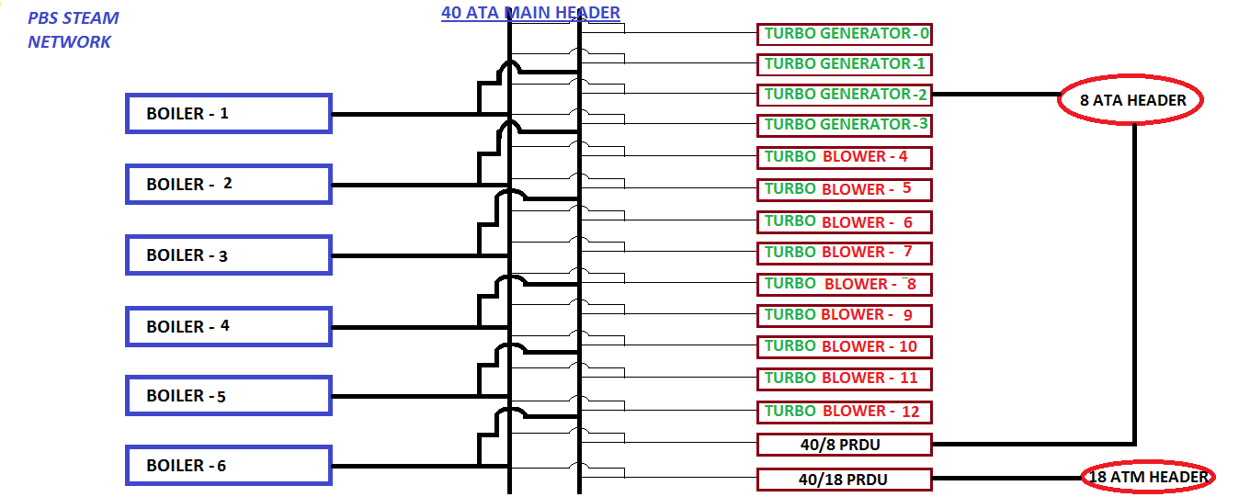

**8 ATA STEAM NETWORK:-**

The following block diagram shows the consumers of 8 ATA process steam. Consumers are:-

* + 1. **BLAST FURANCE:-**

BF is a counter current heat and mass exchanger, in which solid raw materials are charged from the top of the furnace and hot blast is sent through the bottom via tuyeres. The heat is transferred from the gas to the burden and oxygen from the burden to the gas. Gas ascends up the furnace while burden and coke descend down through the furnace. The counter current nature of the reactions makes the overall process an extremely efficient one.

FUNCTION OF STEAM- Steam is injected with hot blast via tuyeres in blast furnace in mixed condition with hot air to increases humidity of the air.

1. As a pursing material
2. It provide inert atmosphere.
3. As a cooling agent
4. It maintain the permeability as hydrogen is a light gas so easily escape.
5. As a reducing agent
   * 1. **SINTER PLANT :-**

Sinter is a porous, lumpy agglomerate of ore fines, waste solid, coke fuels, sized flux and other metallurgical wastes.

Thus sinter plant produce fluxed or super fluxed sinter by utilizing metallurgical wastes.

FUNCTION OF STEAM IN SINTER PLNAT:-

* 1. To increase strength of sinter: - steam is a high capacity energy carrier.
  2. As a purging agent: - During idle time all hazardous, toxic and harmful gases has to be cleaned from pipe line. So steam is injected in pipe line and light gases are taken away with steam.
  3. **RSM, AUXILIRY SHOP AND BY PRODUCT PLANT:-**

In Rail Structural Mill and Auxiliary Shop steam is used as purging agent.

In By product and Tar Plant steam serves two purposes one is as purging agent other one is being as process steam. Sulphur is melt by transferring heat from steam to solid fine Sulphur using heat exchanger tubes.

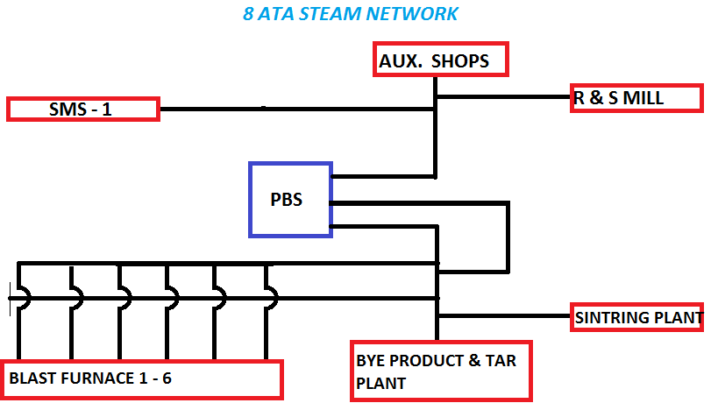

**18 ATA STEAM NETWORK:-** 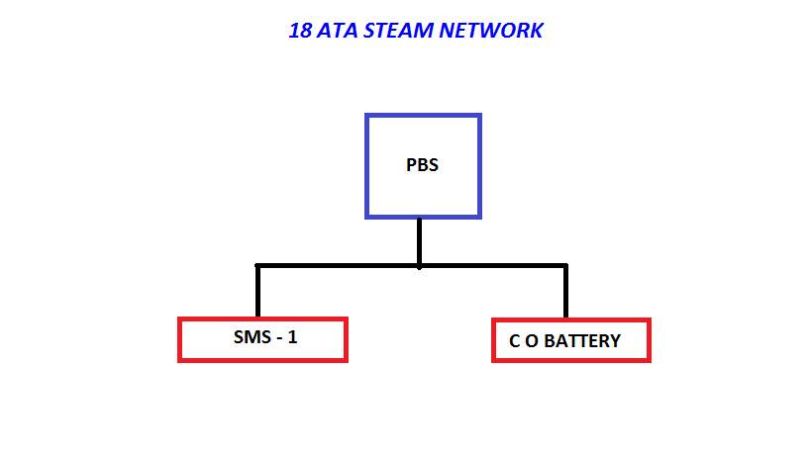

* 1. **STEEL MELTING SHOP -1** :-

Steel Melting Sop - 1 (SMS-1) follows the conventional route of steel making in which steel is produced through Twin Hearth furnaces and cast into ingot moulds. The ingots are stripped off from the ingot moulds and are sent to BBM for further heating and rolling into blooms.

Function of steam

* 1. 8 ATA steam is used as purging agent
  2. 18 ATA steam:-
     1. It gives heat to PCM oil and maintain surface temperature.
     2. Increases injection pressure of PCM oil.

**2. Coke oven battery**:-

In coke oven battery steam serves the following requirement:-

Steam is used as a suction medium of coke oven gases during charging of coal in battery. Based on temperature difference gases are sucked by the steam. (Venture effect)

5. Losses calculation

Proposed allocation for medium and low pressure steam



Steam is supplied by two power plants, for above stated consumer, one is POWER AND BLOWING STATION -1 AND second is NSPCL (JOINT VENTURE WITH BSP).

**Steam distribution losses of PBS -1**

|  |  |  |  |  |  |  |
| --- | --- | --- | --- | --- | --- | --- |
|  |  |  |  |  |  |  |
| **S.no.** | **Consumers of steam** | **Steam flow rate used by consumer(Ton/hr)** | **T at Bleeder (**◦C) | **P at bleeder(kg/cm**²) | **T at Consumer(◦C)** | **P at Consumer(kg/cm²)** |  |
| 1 | BF-1 | 3.14 | 320 | 4.6 | 262 | 3.44 |
| 2 | BF-2 | 4 | 320 | 4.6 | 253 | 4 |
| 3 | BF-3 | 4 | 320 | 4.6 | 217 | 4.6 |
| 4 | BF-4 | 4 | 320 | 4.6 | 210 | 2.8 |
| 5 | BF-5 | 4.18 | 320 | 4.6 | 198 | 2.49 |
| 6 | BF-6 | 2.82 | 320 | 4.6 | 162 | 4.6 |
|  | TOTAL (AVG) | 22.14 |  |  |  |  |

**Calculation:-**

**(1) From 8/13 Bleeder:-**

**(A) Blast Furness Line:-**

= 4.6 kg/cm², = 320 ◦C

= 3107.03 KJ/kg, = 22.14 ton/hr.

Total Energy Inlet=

E In = 68789644.2 KJ/Hr.

**At BF-1**

= 3.44 kg/cm² = 262◦C = 2991.15 kJ/kg 1=3.14 TPH

Energy E1=1 = 9391740 KJ/Hr.

**At BF-2**

= 4 kg/cm² T2= 253◦C h2 = 2970.98 kJ/kg 2=4 TPH

Energy E2=2 =11883920 KJ/Hr.

**At BF-3**

= 4.6 kg/cm² = 217◦C = 2894.23 kJ/kg 3=4 TPH

Energy E3=3 = 11572920 KJ/Hr.

**At BF-4**

= 2.8 kg/cm² = 210◦C = 2887.6 kJ/kg 4=4 TPH

Energy E4=4 = 11550400 KJ/Hr.

**At BF-5**

= 2.49 kg/cm² = 198◦C = 2864.6 kJ/kg 5=4.18 TPH

Energy E5=5 = 11974028 KJ/Hr.

**At BF-6**

= 4.6 kg/cm² = 162◦C = 2773.51 kJ/kg 6=2.82 TPH

Energy E6=6 = 7821298.2 KJ/Hr.

Total Energy Outlet E Out = E1 + E2 + E3 +E4 +E5 + E6

E Out = 64194306.2 KJ/Hr.

**Losses** = E In - E Out

= 4595338 KJ/Hr. **(6.68%)**

**Direct Losses to atmosphere = 13.23 %**

|  |  |  |  |  |  |  |
| --- | --- | --- | --- | --- | --- | --- |
|  |  |  |  |  |  |  |
| **S.no** | **Consumers of steam** | **Steam flow rate (Ton/hr.)** | **T at PRDS (◦C)** | **P at PRDS (kg/cm²)** | **T at Consumer (◦C)** | **P at Consumer(kg/cm²)** |
| **1** | **SMS-1** | **5** | **418.4** | **8.29** | **320** | **8.2** |
| **2** | **COKE OVEN BATTERY** | **12.26** | **400** | **2.24** | **127** | **1.8** |
| **3** | **SINTER PLANT** | **4** | **400.4** | **2.24** | **130** | **1.8** |

**(b) SMS-1(40/18 ATA)**

**From PRDS to SMS-1(40/18 ATA),**

= 8.29 kg/cm², = 418.38 ◦C

= 3307.3 KJ/kg, = 5 ton/hr.

= 8.2 kg/cm², = 320 ◦C

= 2808.5 kJ/kg

Heat loss = ( )

= 5= 2494000 KJ/hr. **(15%)**

**(c) C O BATTERY (40/18 ATA)**

**From PRDS to SMS-1,**

= 2.24 kg/cm², = 400 ◦C

= 3277 KJ/kg, = 12.86 ton/hr

= 1.8 kg/cm², = 127 ◦C

= 2727.5 KJ/kg

Heat loss = ( )

= 12.86= 7066570 KJ/hr. **(16.7%)**

**(d) SINTER PLANT (40/8 ATA)**

**From PRDS to SINTER PLANT,**

= 2.24 kg/cm², = 400.44 ◦C

= 3307.3 kJ/kg, =4 ton/hr

= 1.8 kg/cm², = 130 ◦C

= 2730 KJ/kg

Heat loss = ( )

= = 2309200 KJ/hr. **(17.4%)**

6. CONCLUSION

Usually there is the aim to minimize the friction losses, heat losses and drain leakage in steam lines of any power plant. Often, this is the primary goal and proper utilization of pipe length (shortest route to carry steam), proper insulation and installation of well working drain valve are favorable solution. However, in Bhilai steel plant, most of the plants use old technology, therefore only a very small proportions of waste steam is utilize including turbo blower and turbo generator condensate (initially exhauster steam also feeds back to boiler but not now). At present all the consumers of PBS-1 don’t feed condensate back to the boiler this is the biggest loss because we demineralized water for water this require a lot of input. So utilization of used steam by condensing might reduce the steam losses and will increase power plant efficiency to a remarkable extent. Insulation is the main factor in heat losses, glass wool (or mineral wool) with aluminum coating is commonly used, according to diameter of standard value of insulation is provided. But provided insulation should be repaired within a time interval but as it is seen in BSP many steam pipe lines not having proper insulation which are leading huge heat losses. Friction losses can be minimized by avoiding unnecessary bend, trap (for drain), reducer and expander in steam line. This study will result in a net return to any integrated steel plant by the recovery of steam losses. Recovery of steam losses will result reduced specific fuel consumption and which lead reduced cost of fuel and substantial reduction in steam generation cost through this work i.e. proper insulation, proper trap for drain. Implementation of this solution will definitely increase overall efficiency of power plant. BSP is not too far to recover all their pipe line insulation and proper maintenance of steam line.

7. REFERENCE

1. GATEWAY: An introductory guide to BSP (SAIL BSP)

2. https://www.**sail**-bhilaisteel.com